# 🛡️ Writing Well Constitution and Statement of Purpose

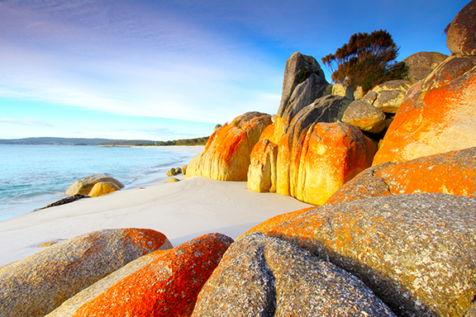

Prepared by: Paula Thwaite, Founder & Lead Facilitator

Website: www.writingwell.net

Email: [paulaanne@writingwell.net](mailto:paulaanne@writingwell.net)

---

1. Name of Group

The group shall be called Writing Well Community Focused Creative Writing Wellbeing Groups, known as Writing Well.

---

2. Mission Statement

Writing Well exists to nurture emotional expression, personal growth, and spiritual reflection through the power of creative writing.

We create safe and inclusive spaces—both online and in-person—where individuals can explore their authentic voice, process life experiences, and grow as writers in community. Rooted in Christian values of compassion, dignity, and transformation, Writing Well welcomes people of all faiths or none, and encourages creative expression that heals, honours, and empowers.

---

3. Vision

To see individuals—regardless of background, ability, or experience—discover confidence, healing, and clarity through writing.

To create a ripple effect where written words become acts of courage, self-awareness, and community care.

---

4. Values

1. Authenticity

We believe each person has a story worth telling and the right to express it in their own voice.

2. Compassion

We offer gentle encouragement, listen without judgment, and foster emotional safety.

3. Inclusivity

We welcome people of all backgrounds, beliefs, and abilities, and hold space for spiritual expression that honours diversity.

4. Creativity

We value freedom, imagination, and the written word as sacred tools for exploration and healing.

5. Respect & Confidentiality

We protect the stories shared in our space and honour one another’s boundaries.

6. Reflection & Growth

We write not to perform, but to grow. We encourage ongoing personal and creative development.

---

5. Activities of the Group

Writing Well will offer:

Fortnightly in-person writing sessions

A WhatsApp group for ongoing support, prompts, and community

Online CPD-accredited courses for professionals (to be developed in 2026).

Seasonal workshops, creative resources, and writing retreats (to be developed in 2026).

Pop-up writing workshops in other regions upon request.

Corporate workshops for professional and personal development.

A Yearly Membership Scheme offering exclusive discounts to carefully selected literary resources (please enquire for details.)

An annual creative writing competition: The Arclight Award ©️Paula Anne Thwaite, presented by a respected member of the literary world who supports our mission.

Regular social meet-ups upon request – sharing tea/coffee and friendly supportive chat. A friendship circle.

Optional one-to-one support or signposting for participants seeking further help.

Optional and seasonal competitions open to the public, to raise money for the Writing Well Mission.

---

6. Safeguarding and Boundaries

Writing Well is not a therapy group, but the writing process may feel cathartic. We commit to:

Upholding emotional safety in all settings.

Responding appropriately to any concerns about participant wellbeing.

Signposting to professional mental health and crisis services when needed.

Operating within safe, ethical boundaries as group facilitators.

---

7. Accessibility and Equality

We are committed to making Writing Well an accessible, inclusive environment.

We will adapt our delivery wherever possible to support participants with disabilities, neurodivergence, or other access needs.

We avoid assumptions and promote diverse voices.

We offer space for participants to contact the facilitator confidentially with specific accessibility needs.

---

8. Leadership and Structure

Writing Well is currently led by Paula Thwaite, founder and lead facilitator. However, we aim for a person centred non hierarchical community.

As the group develops, additional volunteers, guest facilitators, or advisors may support the delivery of sessions and resources.

Writing Well currently have a volunteer Secretary/Administrator, Kirsty Leanne Richardson and a Disability Supporter, Barrie Foster

Writing Well currently seeks a financial administrator, a social media person, a reserve group facilitator and a membership secretary, plus membership to an external group facilitators organisation for professional supervision. Currently supervision is provided by Barrie Foster who has 30+ years experience in psychotherapy and counselling, including facilitating groups/workshops. (We are seeking professional external supervision for group facilitators.)

Paula retains authorship over Writing Well’s original materials and is committed to its ongoing vision, pastoral integrity, and participant wellbeing.

---

9. Faith and Spirituality

While Writing Well is gently rooted in Christian values—compassion, stillness, creative freedom, and transformation—it is not a religious group.

Faith-based reflections are offered as optional invitations, and all spiritual or secular expressions are respected.

---

10. Feedback, Reflection, and Review

Writing Well values reflection, openness, and continued growth.

Participants are encouraged to offer feedback on group experience, accessibility, and impact.

This Constitution will be reviewed annually by the facilitator and, where appropriate, by trusted advisors. (AGM for 2026 to be arranged).

Facilitator and volunteer meetings are held every 4 months and minutes will be taken starting 30th September 2025. All Registered Members are welcome to these meetings. (If you are interested in becoming a member of our committee, please contact Paula 07969 849 294.)

---

Writing Well is more than a writing group. It is a community where words restore, stories connect, and creative faith leads us home.

It is our Mission to help the writer discover their true authentic self, breaking through any blockages, developing creativity, and writing in whatever style helps to reach the authentic self. There is never any pressure, only friendship and encouragement. And, very often, the pathway to writing a piece can be a creative adventure of an activity other than writing itself. We are all unique.

Dated: 3rd August 2026

Signed: *Paula Anne Thwaite*